Cost of living help
As the cost of living crisis continues, the next few months are going to be harder for many people in Shropshire in lots of different ways and in October we expect the next unwelcome energy price rise to hit so many who are already hard-pressed.
We are working alongside partners in Citizens Advice, Shropshire Food Poverty Alliance, Marches Energy Agency, Age UK and Community Research to bring together key resources and support available across Shropshire, so you know the best place to get support.
If you are worried about money or are struggling, you are not alone.
The good news is there is help available – click here to see our cost-of-living help webpage which details the help available from us and partner organisations.
Please do not wait to get help.
We, alongside many support organisations, are already seeing a rise in the number of people seeking help and, as winter approaches, we expect to see the numbers increase.
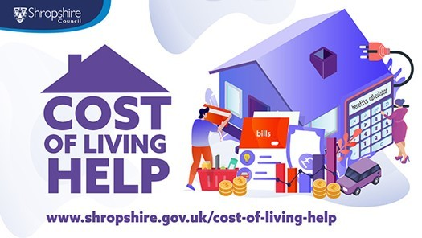
Energy rebate and other help
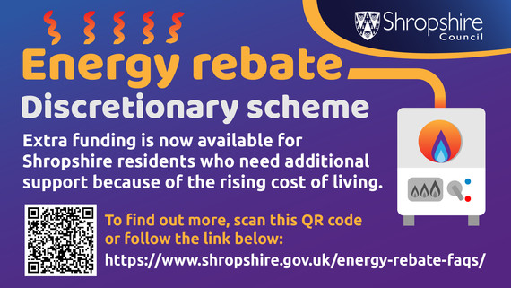
We have now paid more than 88% of the £150 energy rebates, totalling £14.7 million and we are working hard to process the remaining payments by the end of September.
We've also launched some extra help for specific groups among those being hit by rising household costs.
These discretionary payments can help you if you are:
- Claiming council tax support and your home is in a council tax band E-H property.
- A working age adult on council tax support as of 1 April 2022 up to 1 August 2022.
If you are eligible, you do not need to contact us. We will start making discretionary payments before the end of November to those who need it most.
Direct payments will be made where we hold bank details. If we do not have bank details, we will contact you.

